WEBSITE PRAYER WALL
How can we pray for you? We have set up a Prayer Wall link on our homepage for all who visit to post a prayer request and to pray for others. Let’s face it we all have quite a few extra minutes to fill lately…why not spend those moments with God? Go to www.fbcseguin.org and click the Prayer Wall link. Type out your request, be sure to fill in your name and click submit.

FIRST BAPTIST CHURCH FACEBOOK LINKS
Just in case you were not aware, our G-Force Ministry and our Youth Ministry have their own Facebook pages. Teachers are posting weekly a variety of Sunday School lessons and (for the younger ones) crafts to do at home. Be sure to give the page a “thumbs up” so new posts come straight to your feed. Please note that the G-Force page is a private page SOLELY for the protection of our children. To request access to the page, please “friend” Dawn Krause on Facebook and she will add you to the page.
G-Force Page: G-Force Parents
Youth Ministry Page: FBC Seguin Student Ministry

TITHING & ONLINE GIVING
We have multiple options available for you to give to the church.
- Stop by or mail in your tithe - we are in office 5 days a week, 8:00 AM – 5:00 PM.
- Set up an automatic check to be sent directly from your bank.
- Give online - go to www.fbcseguin.org - click on the “Giving” tab at the top of the home page, then fill out the secured form (your info is not stored on our server) and press Submit.
Thank you for your faithfulness to support our church.

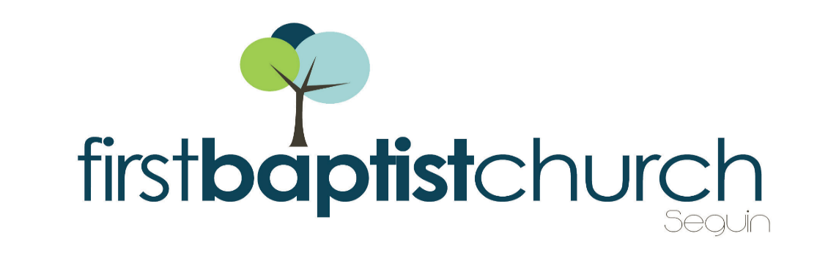
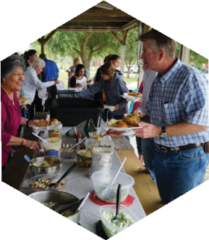
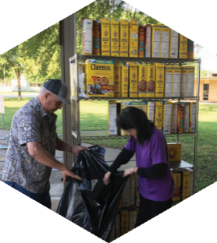

Pastor: Dr. Brice Mandaville
Youth Minister: Josh Graham
Children’s/Volunteer Coordinator: Rhonda Hensarling

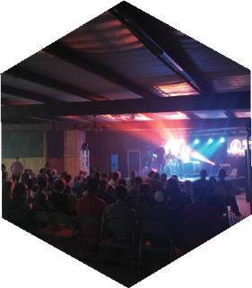
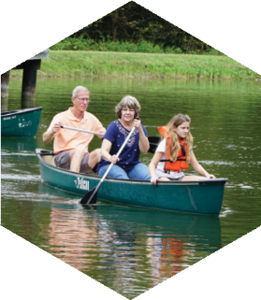
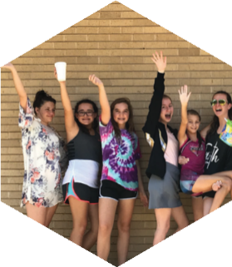
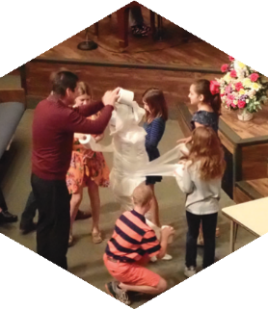
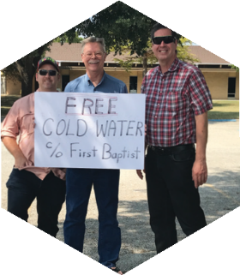

www.fbcseguin.org
830.379.4208
1314 E. Cedar St.

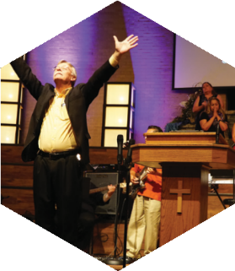

MORNING SERVICE
April 19, 2020 10:30 AM

WELCOME AND ANNOUNCEMENTS
Pastor Brice

WORSHIP MEDLEY Congregation
There’s Power in the Blood
Your Grace Finds Me

SCRIPTURE: 1 Peter 1:8-12, 23-25
Rhonda Hensarling

SERVICE UPDATE Pastor Brice

WORSHIP MEDLEY Congregation
King of My Heart
Living Hope
How Deep The Father’s Love For Us

STANDING AS A ROCK IN THE STORM Pastor Brice

RESPONDING TO GOD’S WORD Congregation
The Old Rugged Cross

For more information about the church, please feel free to explore our website!
www.fbcseguin.org

MEALS ON WHEELS
As a church, we are always looking for ways to increase our presence in the community. During these extraordinary times, we have an opportunity to do just that! We encourage you to join us in our Meals on Wheels ministry by becoming a driver for the program – bringing fresh, homecooked meals to those who are homebound and unable to cook for themselves. Applications can be found online at our website (click on the Serve Seguin tab on the home page) and are also available in the church office. This form requires a signature. Please download and print the form from our website, complete it and turn it in to Rhonda Hensarling in the church office.

MINISTRY OPPORTUNITY
Face masks! There is a big need for them in our community right now and we would like to invite you to join us in providing our local hospital, our Meals on Wheels delivery teams, and, if you feel up to it, your church office staff and custodian with cloth face masks to help slow the spread of COVID-19. We have also partnered with a church member to bring the Austin State School much needed masks for their residents and staff as well. Whether you are a lifelong sewer or are slightly crafty by nature, we hope to get your help in making a few cloth masks. An online tutorial for sewing masks can be found at:
https://www.makershabitat.com/blogs/the-maker-s-habitat-blog/diy-covid-19-fabric-mask-with-filter-pocket-instructions
or (for you non-sewers out there)
https:www.cdc.gov/coronavirus/2019-ncov/prevent-getting-sick/diy-cloth-face-coverings.html
Completed masks should be brought to the church office for distribution to each ministry. Please be in prayer about how you can help our church minister to our community and beyond with face masks (of all things).

