MEALS ON WHEELS
As a church, we are always looking for ways to increase our presence in the community. During these extraordinary times, we have an opportunity to do just that! We encourage you to join us in our Meals on Wheels ministry by becoming a driver for the program – bringing fresh, homecooked meals to those who are homebound and unable to cook for themselves. Applications can be found online at our website (click on the Serve Seguin tab on the home page) and are also available in the church office. This form requires a signature. Please download and print the form from our website, complete it and turn it in to Rhonda Hensarling in the church office.

PRAYER WALL & MAILING LIST
Do you have something we can pray for? Are you looking for ways to pray for your church family? We encourage you to check out our prayer wall, accessed via a quick link on our website homepage. Submitting a prayer request or praise is simple. Click the prayer wall link, fill out the form (most importantly the name and request), then press submit. While you are looking around the website, be sure to sign up for our weekly emails. At present we are sending multiple emails throughout the week to keep our church members and families informed of all church “activities” and happenings. To sign up, go to the church website homepage, click the envelope icon under Join our Mailing List. You may be asked “how you want to open the app.” Click the application icon that you use for daily email. An email with Holly’s church address will come up. Fill in the body of the email and hit send. Holly will take it from there!

For more information about the church, please feel free to explore our website!
www.fbcseguin.org

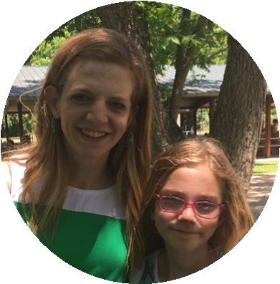
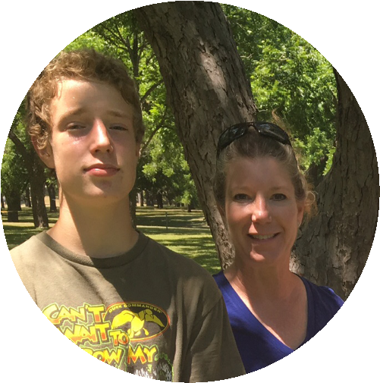
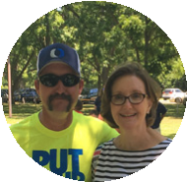
FIRST TIME HERE?
Text Welcome to
830-224-2046

www.fbcseguin.org
830.379.4208
1314 E. Cedar St.

MORNING SERVICE
May 10, 2020 10:30 AM

WELCOME Pastor Brice

WORSHIP MEDLEY Congregation
Praise to the Lord the Almighty
Better Is One Day

A WORD FROM THE PASTOR Pastor Brice
Mother’s Day Flowers
Results of Congregational Survey
My Favorite Phone Call this Week

WORSHIP MEDLEY Congregation
Doxology
WayMaker
For You Are Holy

SCRIPTURE: 1 Peter 2:18-25 Rhonda Hensarling

CHRISTIAN RELATIONSHIPS PART I - WORK Pastor Brice

RESPONDING TO GOD’S WORD Congregation
Turn Your Eyes Upon Jesus

RECOGNIZING A MOTHER OF THE CHURCH
Video Presentation

MOTHER’S DAY SERVICE
To be a Mother means you are a teacher, a chef, a chauffeur, a doctor, a personal assistant and/or trainer, a cheerleader, a maid, the righter of wrongs and the filling for the cracks of life! How blessed are those who are called mom? Today, we celebrate the moms in our lives with a special Mother’s Day service. We will also use this time to honor a mother of the church as well. Someone who has “mothered” through the years, students and adults alike! We are honored by her love. We hope you will join us as we show her our appreciation!

GRADUATE RECOGNITION
MAY 17
Graduation may look different for many of our seniors this year, but here at the church, it is business as usual! We will be recognizing all our graduates (high school & college) during the morning service, Sunday, May 17. Please send us 3 pictures of your graduate (a baby picture, a middle years picture and their senior picture) to firstbaptistseguin@gmail.com. We are putting together a slide show to honor their hard work through the years. Pictures are due no later than 5:00 PM, May 13.

TITHING & ONLINE GIVING
We have multiple options available for you to give to the church.
- Stop by or mail in your tithe - we are in office 5 days a week, 8:00 AM – 5:00 PM.
- Set up an automatic check to be sent directly from your bank.
- Give online - go to www.fbcseguin.org - click on the “Giving” tab at the top of the home page, then fill out the secured form (your info is not stored on our server) and press Submit.
Thank you for your faithfulness to support our church.

