LOOK WHAT YOU DID!
We would like to take a moment to thank you for your faithful support of the church. Your generosity and love has kept the church going but in addition, has also allowed us to do some rather awesome things over the last few weeks.
We gave $1000 to the Medication Assistance program at GRMC, $1000 worth of food to the Silver Center, and sent an additional $1000 to support the Family Life Center in their mission to help in the community. We were also able to send $1000 to support widows in India and, here locally, we were able to buy and install new home siding for a woman in need, as well as assist in lawn maintenance on her property. God is on the move and we are thankful for each of you and your faithfulness to His mission. From this family to yours – thank you!

SUMMER CAMPS & VBS
Summer is upon us and as per Governor Abbott’s announcement on Monday the 18th, we are getting ready for summer camps and activities for children, preteens, and youth. Listed below are the dates for each camp. If you are interested and feel comfortable allowing your child to attend, please contact the corresponding ministry leader for further details. We will announce specific details regarding each camp as they near.
Youth Camp: June 29 – July 3. Contact Josh Graham
Preteen Camp: TBA. Contact Rhonda Hensarling
VBS: July 20 – 24. Contact Rhonda Hart
Please note that teachers, volunteers, and chaperones are needed for each of these events. If you would be interested in helping in any capacity, please let the church office or the ministry leader know.

For more information about the church, please feel free to explore our website!
www.fbcseguin.org

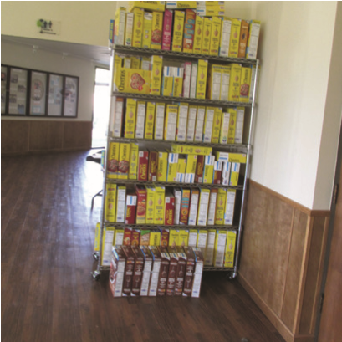
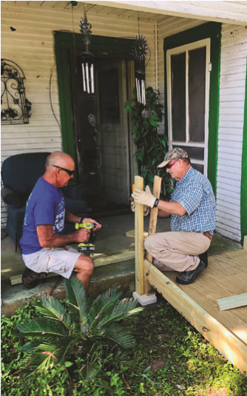
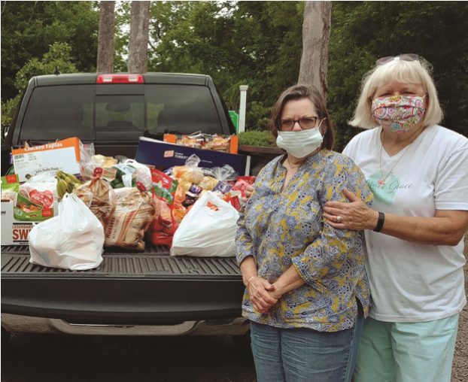
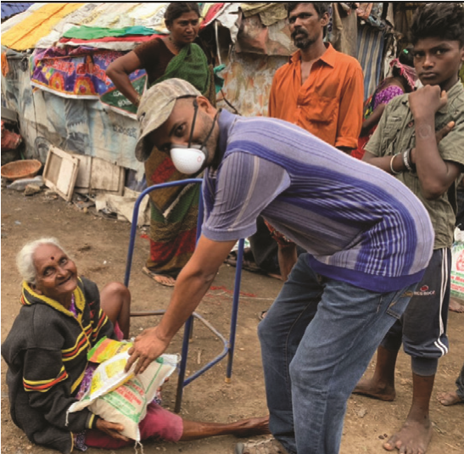
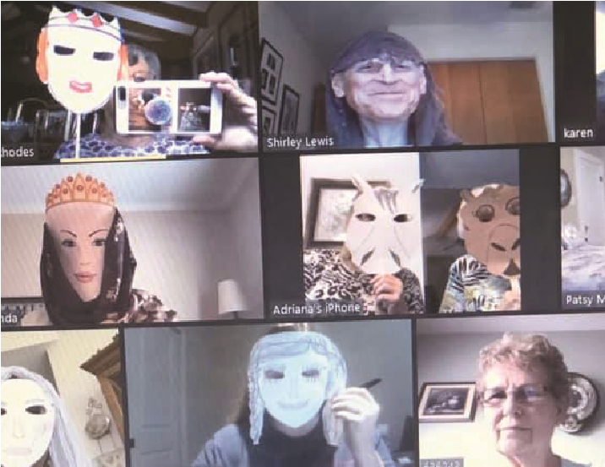
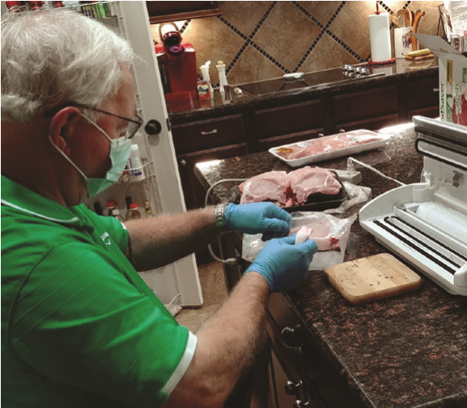
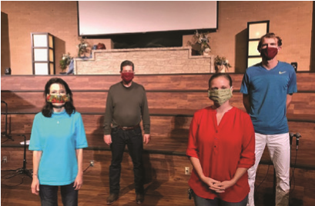
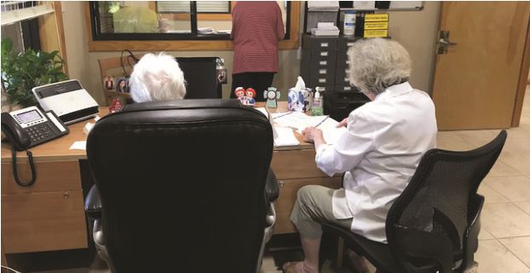
Pastor: Dr. Brice
Mandaville
Youth Pastor: Josh
Graham
Quarantine

Life!

www.fbcseguin.org
Children’s/Volunteer Coordinator: Rhonda Hensarling
MORNING SERVICE
May 24, 2020 10:30 AM

WELCOME Pastor Brice

POSTING OF THE COLORS Young Marines

WORSHIP MEDLEY Congregation
America the Beautiful
Lord I Need You

A WORD FROM THE PASTOR Pastor Brice

WORSHIP MEDLEY Congregation
Living Hope
The Blood Will Never Lose It’s Power
Mercy

MEMORIAL DAY REMEMBRANCE Video

SCRIPTURE: 1 Peter 2:13-17 Rhonda Hensarling

CHRISTIAN RELATIONSHIPS PART III - GOVERNMENT Pastor Brice

RESPONDING TO GOD’S WORD Congregation
Turn Your Eyes Upon Jesus

WELCOME BACK!
We are thrilled to see your smiling faces!

REOPENING
Over the next several weeks, we will be implementing numerous procedures that will enable us to reopen the whole campus. As we move forward, we want you to know that we have yours and your family’s health and safety in our thoughts; any and all forward motion we make, rest assured, has not been made in haste. At present, we have restricted seating in the sanctuary to every other row and have reserved the downstairs seats for those 65 and over. The buildings across the campus will remained closed with the Fellowship Hall open as overflow seating only. As the need arises, we will open other designated areas to view the service. The Kids building will be open for infants through three years old only. We would like to ask that only one parent accompany their child(ren) into the building to keep traffic and exposure to a minimum. Children are also welcome to stay with their parents during the service if this is preferred. We will continue to live stream our services so cameras will be visible and moved throughout the service.
If you would like more information on how the church is staying up-to-date and complying with COVID – 19 procedures and restrictions, please visit our website homepage or sign up to receive our weekly emails.

