RESCUE YOUTH CAMP
JUNE 29 – JULY 3
Youth camp is officially on the calendar and the students are headed to Rescue Youth Camp in Latham Springs, TX. This camp is for completed 6th through 12th grade. Price per camper is $215 and should be paid in full by June 12th. Please make all checks out to First Baptist Church. Registration packets can be found in the church office. Please be sure to have our registration packet filled out and returned no later than June 5th. An informational email has been sent to youth parents with a link to the camp website. There you will find an updated policy for the camp as it pertains to their response to the COVID-19 pandemic. Please contact Josh Graham if you have any questions, concerns, or needs.

VACATION BIBLE SCHOOL
JULY 20 – 24
We are still looking for volunteers to help out with our summer VBS. We need, but are not limited to, the following: teachers, classroom monitors, snack volunteers, REC leaders, registration and music helpers! If you are available during this time, and interested in helping in any way, please contact Rhonda Hart at 830.305.5928.

PRETEEN CAMP AT ALTO FRIO
JULY 27 – 30
Our little ones are headed to Alto Frio this summer for camp Snap Shot! This camp is for completed 3rd – 6th grade and the price per camper is $150. All payments should be made to First Baptist Church. To sign up, please see Rhonda Hensarling.

CAMP SCHOLARSHIPS
We have scholarships available for those in need to both Youth and Preteen camps. We never want money to be the reason a child or student misses out. Please see either Josh Graham or Rhonda Hensarling (respectively) to inquire about scholarships.

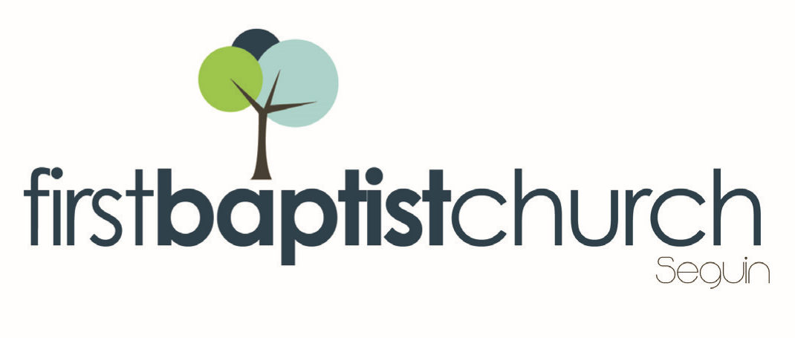
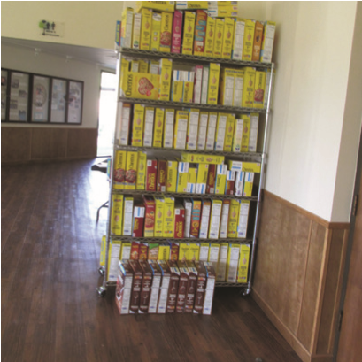
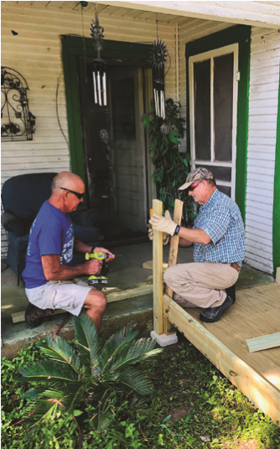
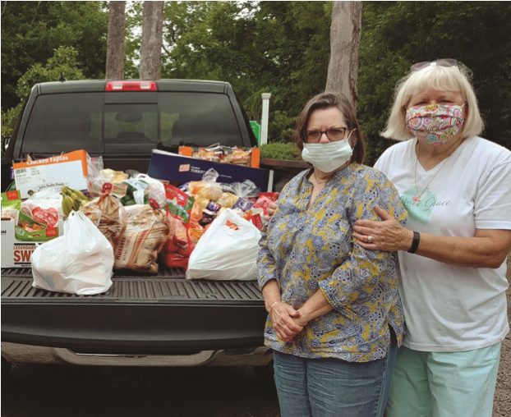
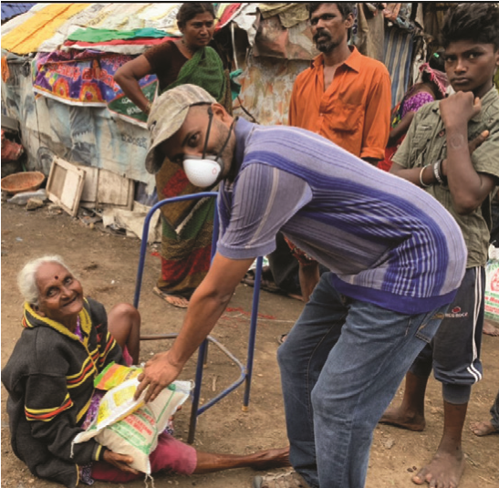
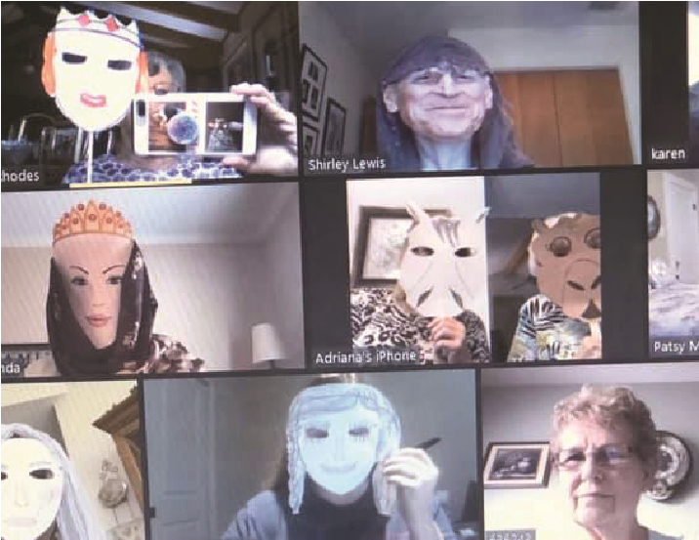
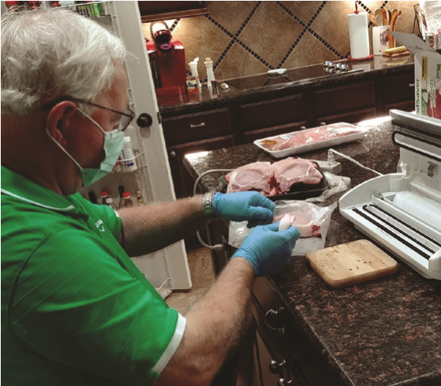
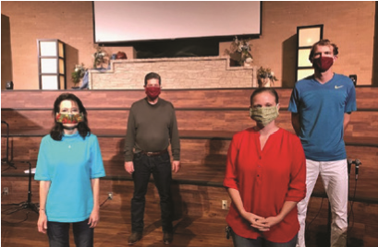
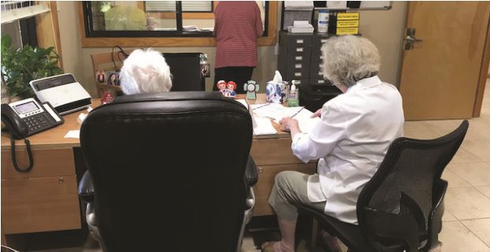
Pastor: Dr. Brice
Mandaville
Youth Pastor: Josh
Graham
Quarantine

Life!

www.fbcseguin.org
Children’s/Volunteer Coordinator: Rhonda Hensarling
MORNING SERVICE
June 7, 2020 10:30 AM

WELCOME/PRAYER Pastor Brice

WORSHIP MEDLEY Congregation
Always
Be Thou My Vision

A WORD FROM THE PASTOR Pastor Brice

GIDEONS’ PRESENTATION Tim Bruchmiller

WORSHIP MEDLEY Congregation
There’s Power in the Blood
For You Are Holy

SCRIPTURE: 1 Peter 4:7-11 Rhonda Hensarling

REACHING ACROSS RACIAL LINES Pastor Brice

RESPONDING TO GOD’S WORD Congregation
Wherever He Leads I’ll Go

GRAIN OFFERING
We have shelves available in the foyer for you to place your grain offering. Thank you for your support of this ministry! If you forgot your box this morning – no worries! You can drop your donation by the office during office hours, Monday – Friday, 8:00 AM – 5:00 PM.

GIDEONS’ PRESENTATION
We are excited to hear from the Gideons this morning! Tim Bruchmiller will be giving a short presentation on their Bible Ministry. We will be taking a dedicated offering for them and any envelopes marked “Gideons” or “Bibles” or loose cash in the offering boxes will go toward the purchase of Bibles to further their ministry.

FATHER’S DAY SERVICE
JUNE 21
“Normal” is inching closer and closer here at the church and we are looking forward to celebrating Father’s Day with our church family. We hope you will join us for a special service, honoring those we call “dad.” We will take a few moments that morning to honor a father of the church with a special gift! Hope to see you there.

For more information about the church, please feel free to explore our website!
www.fbcseguin.org

