4TH OF JULY FIREWORKS
JULY 3
Looking for a great view of the city’s 4th of July fireworks? We have just the place. You and your family are invited to join us at Ernest and Sue Laird’s house for fun and fellowship. Located at 110 Lenz Dr., here in Seguin, the Laird’s have a rolling front lawn for us to set up our lawn chairs for a fantastic showing. This year, unlike in years past, we will NOT have a potluck table. Due to the COVID-19 concerns of late, we are asking that everyone refrain from bringing any food or drinks. Please bring only your lawn chairs and/or blankets. We look forward to seeing you there!

VACATION BIBLE SCHOOL
JULY 20 – 24
Volunteers are still needed to help out with our summer VBS. We need, but are not limited to, the following: teachers, classroom monitors, snack volunteers, REC leaders, registration and music helpers! If you are available during this time, and interested in helping in any way, please contact Rhonda Hart at 830.305.5928.

PRETEEN CAMP AT ALTO FRIO
JULY 27 – 30
Our little ones are headed to Alto Frio this summer for camp Snap Shot! This camp is for completed 3rd – 6th grade and the price per camper is $150. All payments should be made to First Baptist Church. To sign up, please see Rhonda Hensarling.

CAMP SCHOLARSHIPS
We have scholarships available for those in need to both Youth and Preteen camps. We never want money to be the reason a child or student misses out. Please see either Josh Graham or Rhonda Hensarling (respectively) to inquire about scholarships.

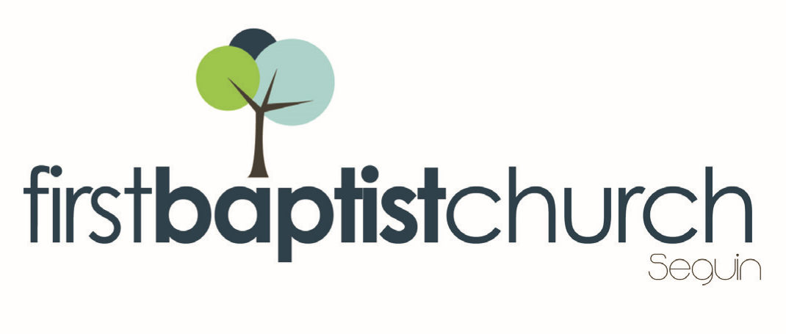
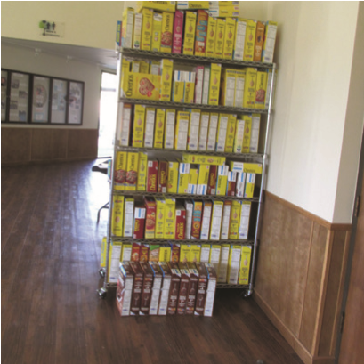
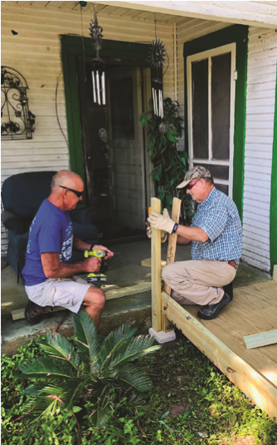
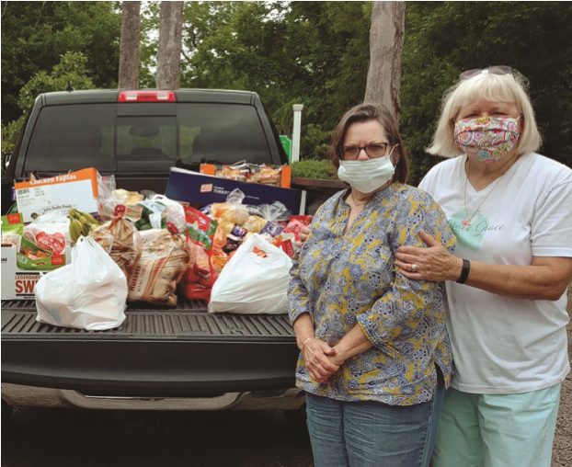
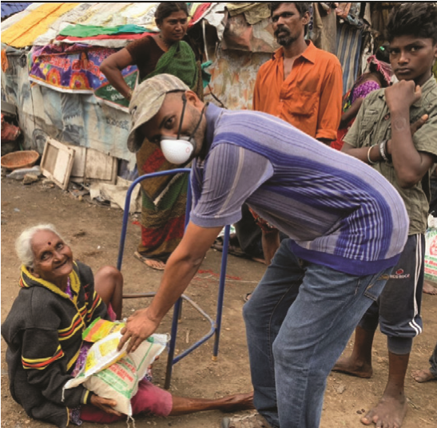
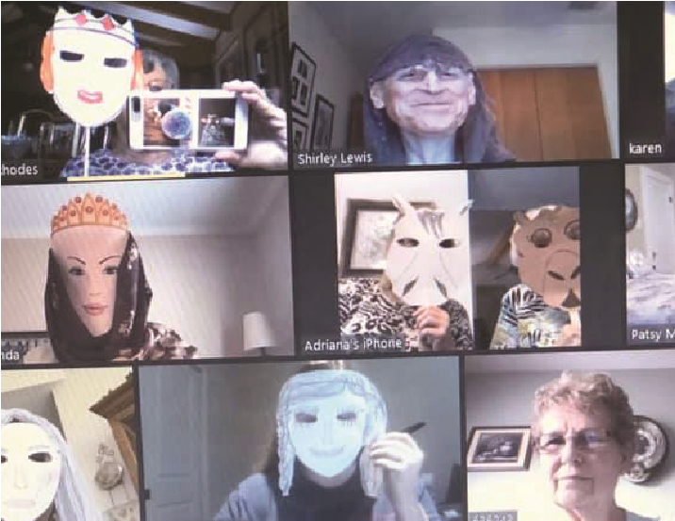
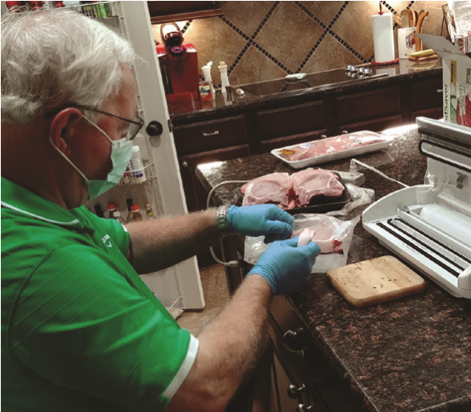
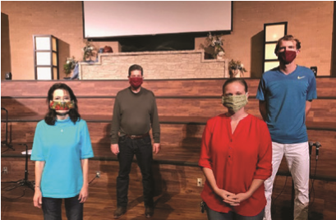
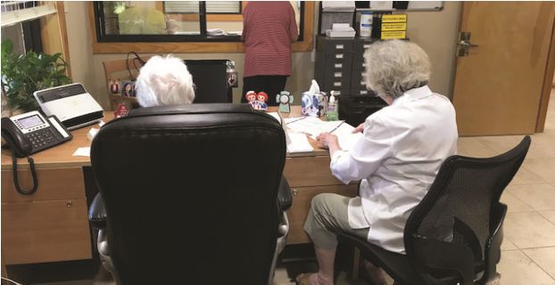
Pastor: Dr. Brice
Mandaville
Youth Pastor: Josh
Graham
Quarantine

Life!

www.fbcseguin.org
Children’s/Volunteer Coordinator: Rhonda Hensarling
MORNING SERVICE
June 14, 2020 10:30 AM

WELCOME/PRAYER Pastor Brice

WORSHIP MEDLEY Congregation
Doxology
The Way of the Lord

A WORD FROM THE PASTOR Pastor Brice

WORSHIP MEDLEY Congregation
Praise to the Lord the Almighty
Lord of My Life
Your Grace Finds Me

SCRIPTURE: 1 Peter 3:18-22 Rhonda Hensarling

CAN A PERSON TURN TO GOD AFTER DEATH? Pastor Brice

PREPARING FOR COMMUNION Congregation
Wherever He Leads I’ll Go

OBSERVANCE OF THE LORD’S SUPPER

CLOSING PRAYER

LORD’S SUPPER
We will be observing the Lord’s Supper a little differently this morning. With your health and safety in mind, we will have the elements double stacked and the Deacons will personally serve you as you sit with your family. If you require a gluten free option, separate wafers can be found at the foyer counter. We call everyone who has accepted Jesus Christ as their personal savior to join us.

FATHER’S DAY SERVICE
NEXT SUNDAY
We hope you will join us for a special service, honoring those we call “dad.” We will take a few moments that morning to honor a father of the church with a special gift! Hope to see you there.

RELAUNCH OF BIBLE FELLOWSHIP GROUPS
TENTATIVE DATE: JULY 12
We are tentatively looking at relaunching our Sunday morning small groups on July 12 (knowing that the situation is always subject to change). We realize that it will look different for different groups, some may meet on campus and others may meet online. The on-campus groups will have precautions in place. It is a work in progress. We will keep you updated as we go.

For more information about the church, please feel free to explore our website!
www.fbcseguin.org

