4TH OF JULY FIREWORKS
JULY 3
Looking for a great view of the city’s 4th of July fireworks? We have just the place. You and your family are invited to join us at Ernest and Sue Laird’s house for fun and fellowship. Located at 110 Lenz Dr., here in Seguin, the Laird’s have a rolling front lawn for us to set up our lawn chairs for a fantastic showing. This year, unlike in years past, we will NOT have a potluck table. Due to the COVID-19 concerns of late, we are asking that everyone refrain from bringing any food or drinks. Please bring only your lawn chairs and/or blankets. We look forward to seeing you there!

YOUTH SUMMER ACTIVITIES
With COVID restrictions lifting and precautions now in place, we are excited to announce that summer plans for our youth are back on the calendar! Mondays will be Movie Mondays! Students will meet in the Youth Building from 5:30 – 7:00 PM to watch a parent-approved movie. Tuesdays are reserved for Disc Golf at Starcke Park. From 4:00 – 6:00 PM your student can enjoy the sunshine and get some exercise while fellowshipping with peers! On to Wednesdays, beginning at 5:30 PM, running until 7:00 PM, Josh Graham will meet with the students at Sonic (on Court St.) for Root Groups. A time for discussion of those hot topics that follow our youth day in and day out. Please be sure to arrange for proper transportation of your child, depending on the location of the event. Tuesday and Wednesday drop offs and pickups will be on location while Monday drop off and pickup is at church. This is some much-needed time of fellowship – we hope to see your student there!

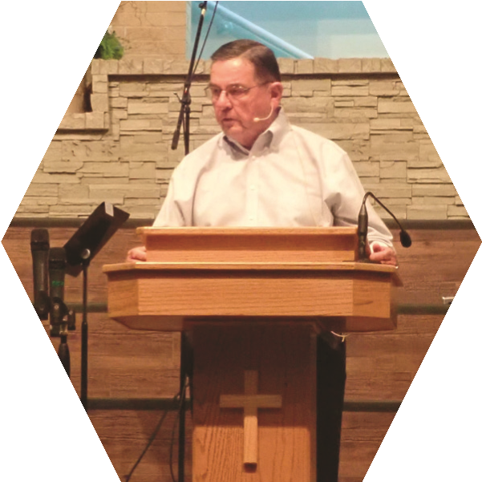
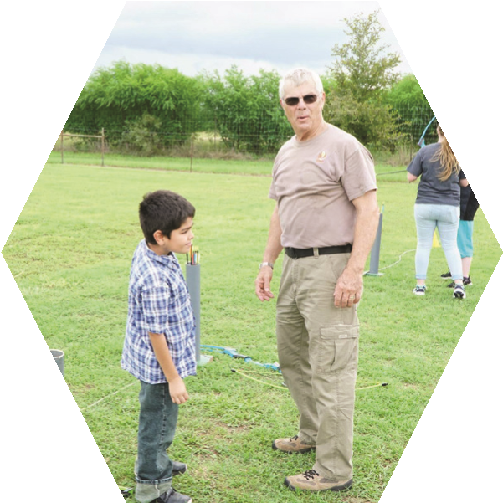
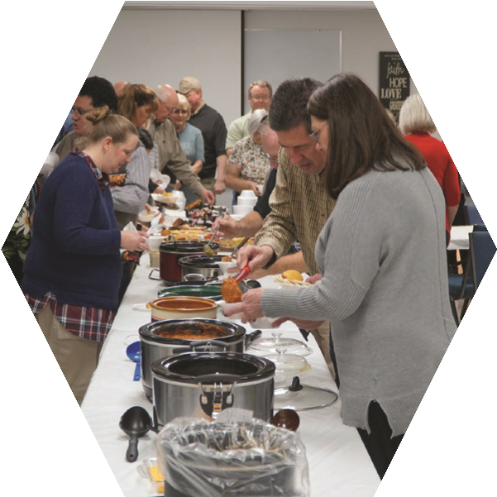
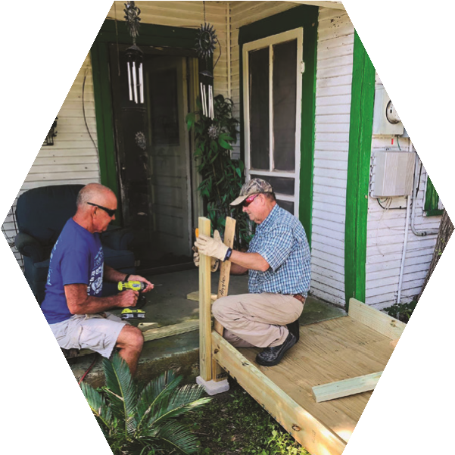
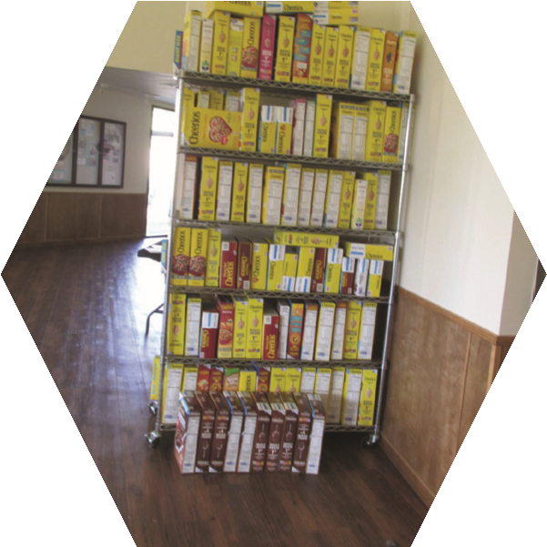
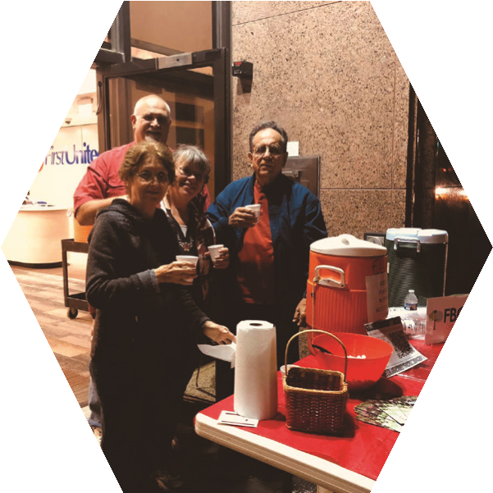
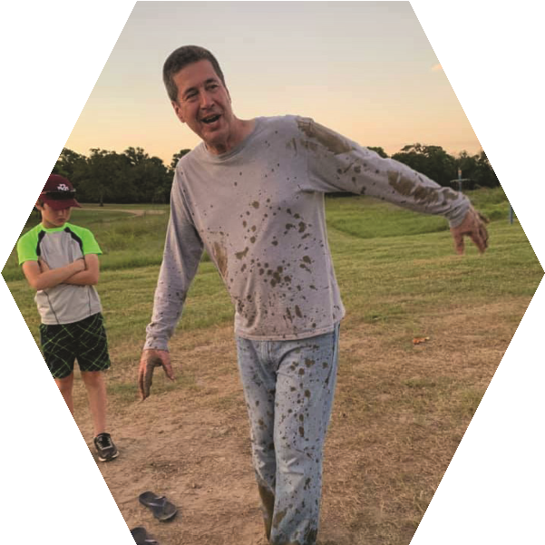
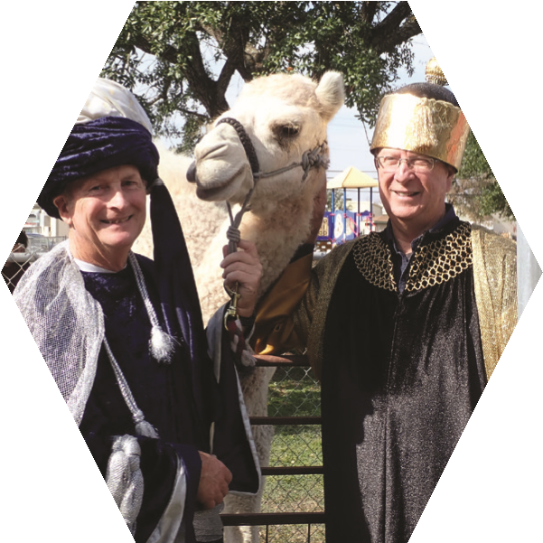
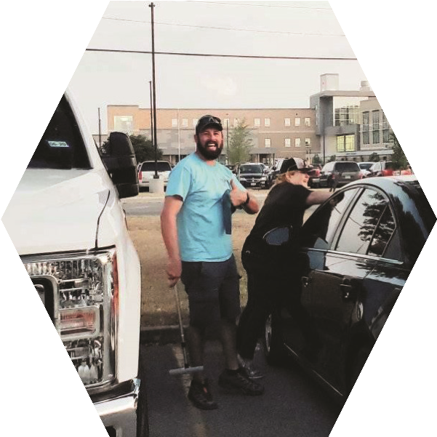
www.fbcseguin.org
Welcome!
Senior Pastor:
Dr. Brice Mandaville
Youth Pastor:
Josh Graham
Children’s & Volunteer
Coordinator:
Rhonda Hensarling
Minister of Music:
Jordan Hagerup

MORNING SERVICE
June 21, 2020 10:30 AM

WELCOME/PRAYER Pastor Brice

WORSHIP MEDLEY Congregation
10,000 Reasons
At the Cross

A WORD FROM THE PASTOR Pastor Brice

THE GOLDEN HAMMER AWARD

WORSHIP MEDLEY Congregation
WayMaker
Because He Lives

SCRIPTURE: 1 Peter 4:1-6 Rhonda Hensarling

CHOOSING TO MAKE YOUR LIFE COUNT FOR GOD Pastor Brice

RESPONDING TO GOD’S WORD Congregation
Wherever He Leads I’ll Go

HAPPY FATHER’S DAY
Thank you for being here for this special service, honoring those we call “dad.” We will take a few moments this morning to honor a father of the church with a special gift!

HERMAN CRAMER PREACHING
NEXT SUNDAY
We are excited to welcome Herman Cramer back to the pulpit, next Sunday, for morning worship! Bro. Brice will be visiting his daughter, something he has not been able to do for a few months now and we have asked Bro. Herman to fill in.

RELAUNCH OF BIBLE FELLOWSHIP GROUPS
TENTATIVE DATE
We are tentatively looking at relaunching our Sunday morning small groups on July 12 (knowing that the situation is always subject to change). We realize that things will look different for different groups, some may meet on campus and others may meet online. The on-campus groups will have precautions in place. Please remember this is a tentative date and subject to change based on a number of factors. It is a work in progress. We will keep you updated as we go.

For more information about the church, please feel free to explore our website!
www.fbcseguin.org

